


PIPER TOOLS AUSTRALIA PTY LTD

2025 COUNTERSINKS

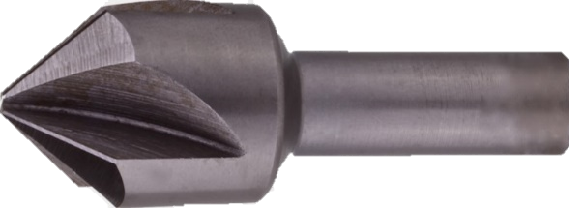
90° 4 Flute Countersink |  |  |  |  | 82° 4 Flute Countersink
PART No. | Max Dia. | Shank Dia. | Price |  | Part No. | Max Dia. | Shank Dia. | Price
CS90-260 | .260" | .200" |  |  | CS82-260 | .260" | .200"
CS90-323 | .323" | .250" |  |  | CS82-323 | .323" | .250"
CS90-385 | .385" | .250" |  |  | CS82-385 | .385" | .250"
CS90-510 | .510" | .375" |  |  | CS82-510 | .510" | .375"
CS90-635 | .635" | .375" |  |  | CS82-635 | .635" | .375"
CS90-760 | .760" | .500" |  |  | CS82-760 | .760" | .500"
CS90-885 | .885" | .500" |  |  | CS82-885 | .885" | .500"
CS90-1010 | 1.010" | .500" |  |  | CS82-1010 | 1.010" | .500"
CS90-1260 | 1.260" | .500" |  |  | CS82-1260 | 1.260" | .500"
CS90-1510 | 1.510" | .625" |  |  | CS82-1510 | 1.510" | .625"
60° 4 Flute Countersink |  |  |  |  | 120° 4 Flute Countersink
PART No. | Max Dia. | Shank Dia. | Price |  | Part No. | Max Dia. | Shank Dia. | Price
CS60-260 | .260" | .200" |  |  | CS120-260 | .260" | .200"
CS60-323 | .323" | .250" |  |  | CS120-323 | .323" | .250"
CS60-385 | .385" | .250" |  |  | CS120-385 | .385" | .250"
CS60-510 | .510" | .375" |  |  | CS120-510 | .510" | .375"
CS60-635 | .635" | .375" |  |  | CS120-635 | .635" | .375"
CS60-760 | .760" | .500" |  |  | CS120-760 | .760" | .500"
CS60-885 | .885" | .500" |  |  | CS120-885 | .885" | .500"
CS60-1010 | 1.010" | .500" |  |  | CS120-1010 | 1.010" | .500"
CS60-1260 | 1.260" | .500" |  |  | CS120-1260 | 1.260" | .500"
100° 4 Flute Countersink
PART No. | Max Dia. | Shank Dia. | Price
CS100-260 | .260" | .200"
CS100-323 | .323" | .250"
CS100-385 | .385" | .250" |  |  | 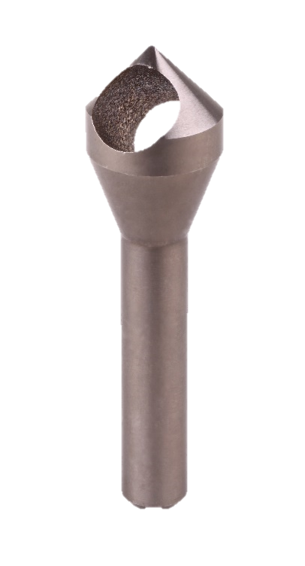
CS100-510 | .510" | .375"
CS100-635 | .635" | .375"
CS100-760 | .760" | .500"
CS100-885 | .885" | .500"
CS100-1010 | 1.010" | .500"
CS100-1260 | 1.260" | .500"
 |  |  |  |  | 82° Cross Hole Countersink
 |  |  |  |  | Part No. | Max Dia. | Shank Dia. | Price
 |  |  |  |  | CH82-37 | 15-37mm | 14mm
 |  |  |  |  | CH82-50 | 25-50mm | 16mm
 |  |  |  |  | 90° Cross Hole Countersink
 |  |  |  |  | CH90-37 | 15-37mm | 14mm
 |  |  |  |  | CH90-50 | 25-50mm | 16mm

