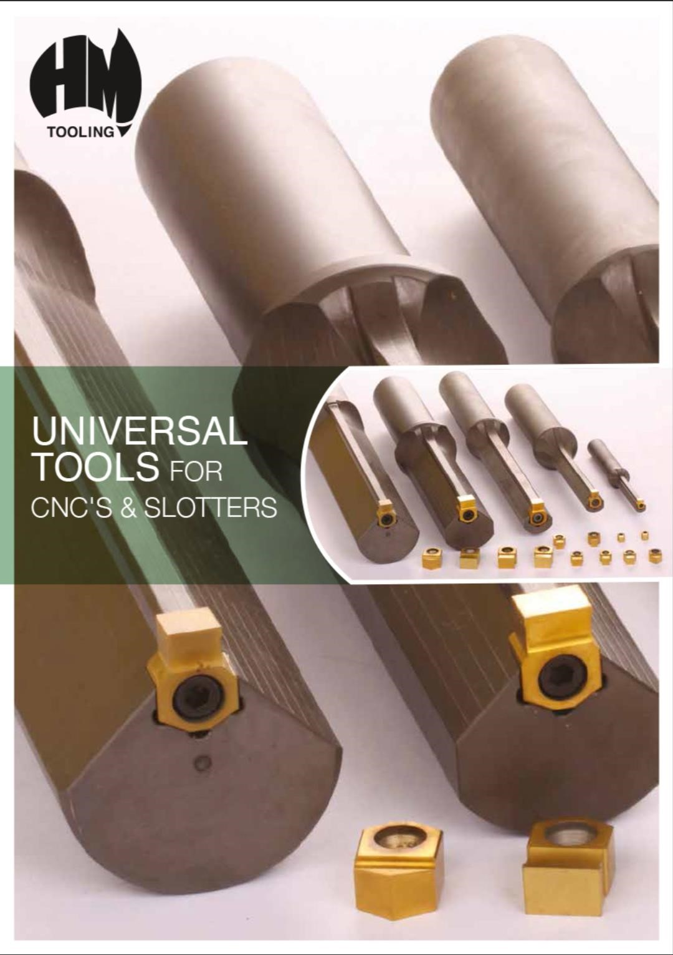
2025


HOLDERS AND INSERTS 2025

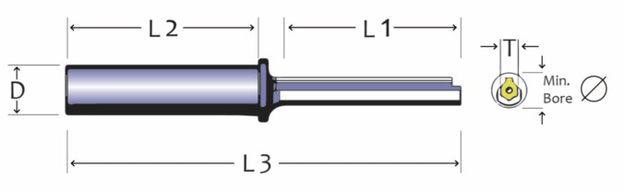

HOLDER

 | 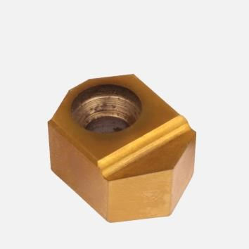  Specials Upon Request  E.g. Splines, squares, hexagon, etc.
  HOLDERS | T | Min ⌀ | D | L1 | L2 | L3
  HMH-0616-35-13 | 6 | 13mm | 16mm | 35 | 70 | 118
  HMH-0616-50-13 | 6 | 13mm | 16mm | 50 | 70 | 133
  HMH-0616-50-16 | 6 | 16mm | 16mm | 50 | 70 | 132
  HMH-1025-60-19 | 10 | 19mm | 25mm | 60 | 90 | 175
  HMH-1025-80-19 | 10 | 19mm | 25mm | 80 | 90 | 195
  HMH-1025-60-22 | 10 | 22mm | 25mm | 60 | 90 | 175
  HMH-1025-60-24 | 10 | 24mm | 25mm | 60 | 90 | 175
  HMH-1032-100-22 | 10 | 22mm | 32mm | 100 | 120 | 245
  HMH-1332-75-32 | 13 | 32mm | 32mm | 75 | 100 | 205
  HMH-1332-100-32 | 13 | 32mm | 32mm | 100 | 100 | 230
  HMH-1332-130-32 | 13 | 32mm | 32mm | 130 | 120 | 285
  HMH-1340-120-48 | 13 | 48mm | 40mm | 120 | 120 | 264
  HMH-1350-200-58 | 13 | 58mm | 50mm | 200 | 120 | 345
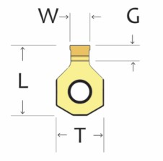

INSERT

 | METRIC INSERTS | T | G | L | W |  | IMPERIAL INSERTS | T | G | L | W
 | HM 0603-02 H7 TiN | 6 | 3 | 8.5 | 2mm |  | HM 0603-0.125 H7 TiN | 6 | 3 | 8 | 0.125"
 | HM 0603-2.5 H7 TiN | 6 | 3 | 8.5 | 2.5mm |  | HM 0603-0.187 H7 TiN | 6 | 3 | 8 | 0.187"
 | HM 0603-03 H7 TiN | 6 | 2.5 | 8 | 3mm |  | HM 1042-0.187 H7 TiN | 10 | 4.2 | 14.92 | 0.187"
 | HM 0603-04 H7 TiN | 6 | 3 | 8 | 4mm |  | HM 1042-0.250 H7 TiN | 10 | 4.2 | 14.92 | 0.250"
 | HM 0603-05 H7 TiN | 6 | 3 | 8 | 5mm |  | HM 1052-0.313 H7 TiN | 10 | 5.2 | 14.92 | 0.313"
 | HM 1042-05 H7 TiN | 10 | 4.2 | 8 | 5mm |  | HM 1362-0.375 H7 TiN | 13 | 6.2 | 20.2 | 0.375"
 | HM 1042-06 H7 TiN | 10 | 4.2 | 14.92 | 6mm |  | HM 1372-0.500 H7 TiN | 13 | 7.2 | 20.2 | 0.500"
 | HM 1052-08 H7 TiN | 10 | 5.2 | 14.92 | 8mm |  | HM 1310-0.625 H7 TiN | 13 | 10 | 20.2 | 0.625"
 | HM 1362-10 H7 TiN | 13 | 6.2 | 20.2 | 10mm
 | HM 1372-12 H7 TiN | 13 | 7.2 | 20.2 | 12mm
 | HM 1372-14 H7 TiN | 13 | 7.2 | 20.2 | 14mm
 | HM 1395-14 H7 TiN | 13 | 9.5 | 24.2 | 14mm
 | HM 1310-16 H7 TiN | 13 | 10 | 20.2 | 16mm

 | MATERIALS | D.O.C FEED/CUT | CUTTING SPEED M/MIN | RAKE ANGLE |  | SPARE PARTS SCREW
 | MILD STEEL | 0.03-0.05 | 2-10 M/MIN | 15-25 |  | HMS06-CSTB2.5L080
 | HIGH TENSILE | 0.03-0.05 | 2-10 M/MIN | 15-25 |  | HMS10-FTNA0415
 | STAINLESS STEEL | 0.02-0.05 | 2-5 M/MIN | 25 |  | HMS13-CSHB-6
 | CAST IRON | 0.04-0.06 | 5-10 M/MIN | 15-20
 | ALUMINIUM | 0.04-0.06 | 5-15 M/MIN | 25
 | BRONZE/BRASS | 0.04-0.06 | 5.10 M/MIN | 0-5

 | 
  METALLICO AUSTRALASIA  3/17 King Road Hornsby NSW 2077  Mb: 0411 575 738  E: tools@metallico.com.au |  | NOTE:  Speeds and feeds are only a guide, cutting conditions will vary with machine, material and the configuration of the work piece.  Rake angle approximately 10 degrees supplied, unless specially ordered. The smallest possible rake angle should be selected to allow free cutting as a higher rake angle will cause chatter and the cutter to be drawn into the work piece.

